The Pelvic Floor Society

Scientific Meeting & AGM

Bristol

30th January 2015

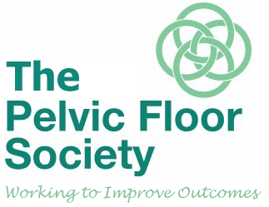

Date

30th January 2015 09.00 – 17.20

Venue
BAWA, 589 Southmead Road, Filton, Bristol, BS34 7RG

Transport
By Rail
Bristol Temple Meads is 8 miles from BAWA Club, Filton, Bristol.
Bristol Parkway is 2.7 miles from BAWA Club, Filton, Bristol.
By Air
Bristol International Airport - BRS - is 12.9 miles from BAWA Club, Filton, Bristol.
By Road: From M4, junction 19, take M32 to city centre. Leave M32 at Junction 1. Take A417 then B4056 1 to Southmead road (appox 3 miles). After 0.5 miles turn right into Southmead Road and building is on your right.
To programme your satnav please use postcode BS34 7RG.
Parking is ample and FREE

