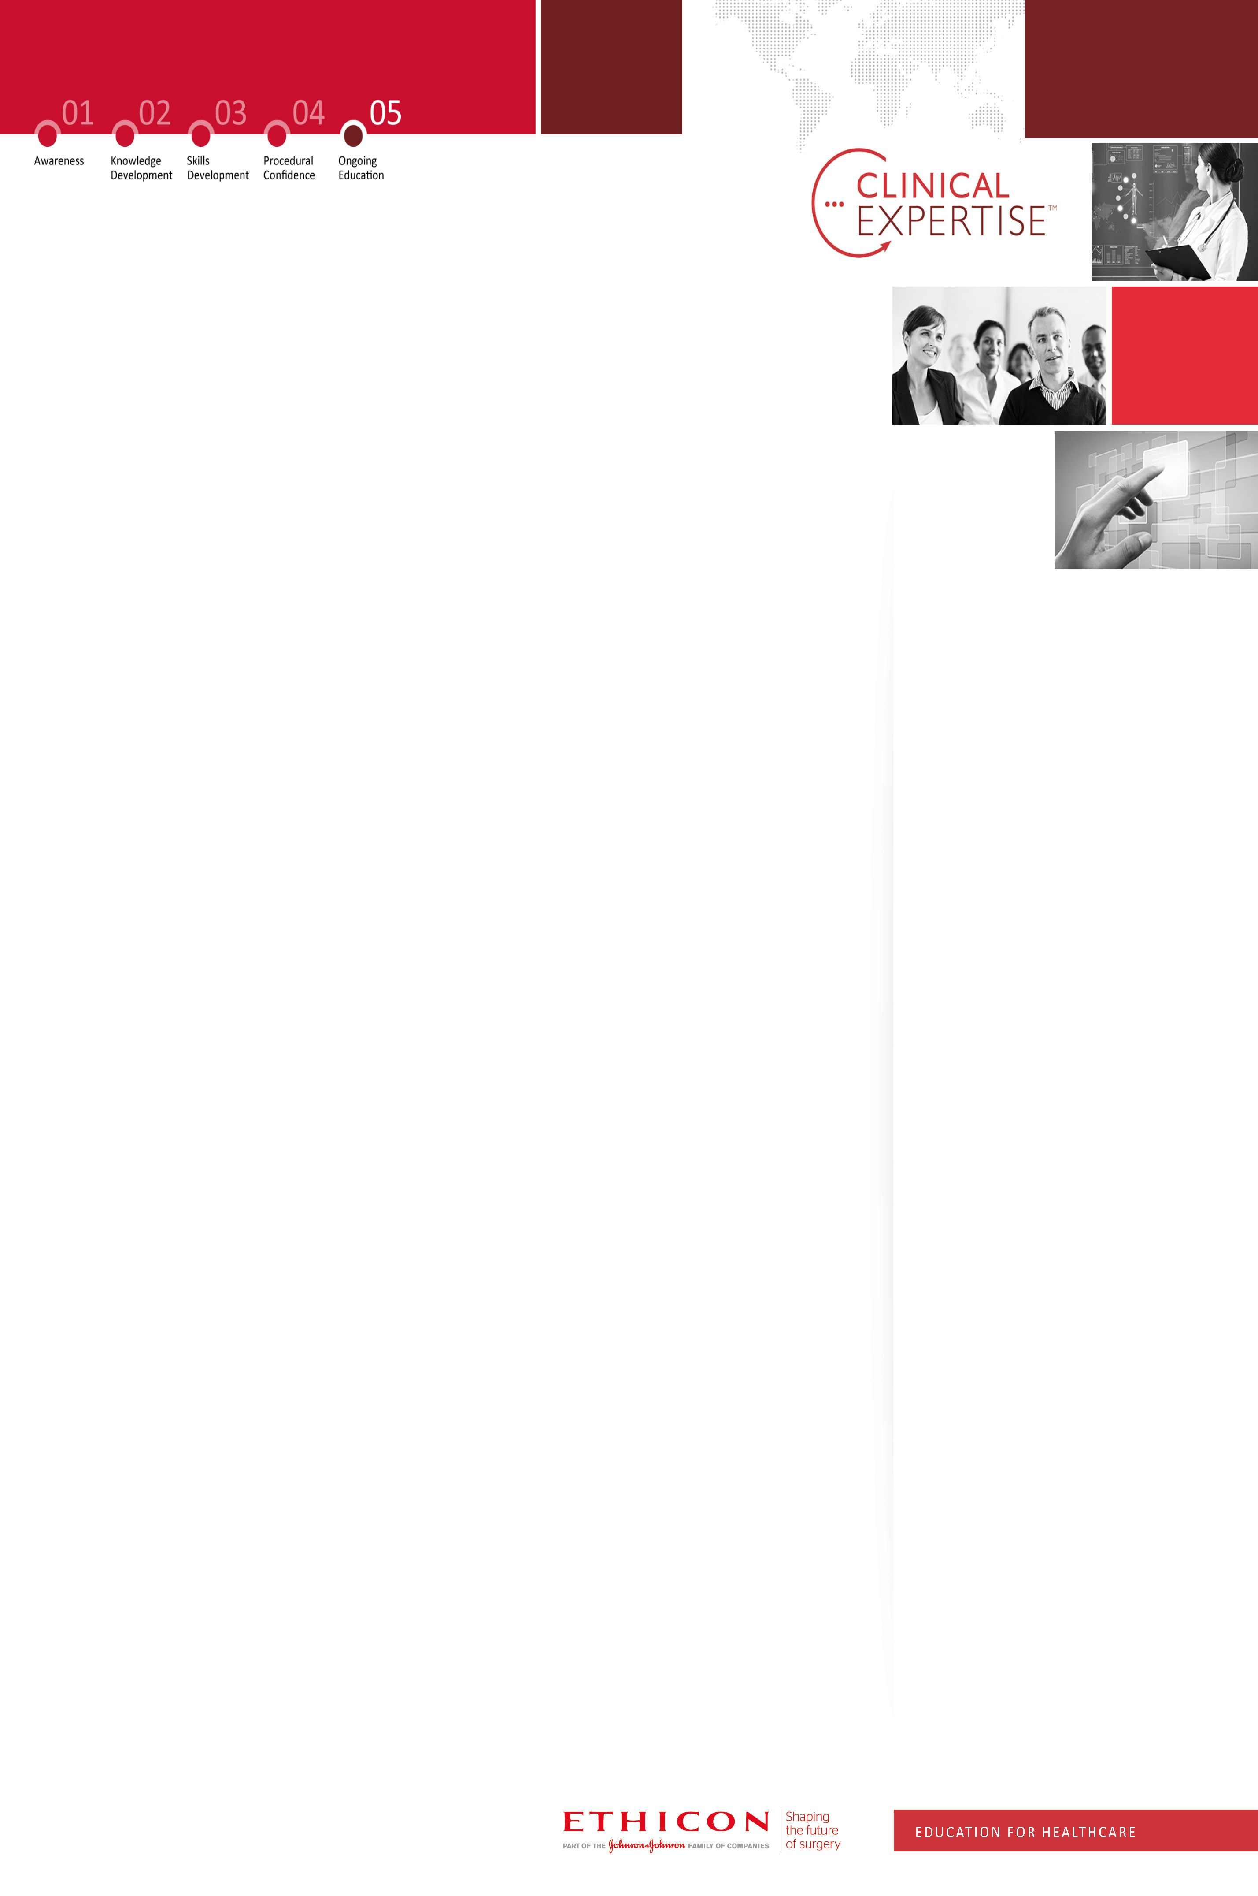
ETHICON & ACPGBI COLORECTAL SYMPOSIUM
Date: 7th October 2015
Location: MATTU, Guildford
MATTU, GUILDFORD
The Minimal Access Therapy Training Unit (MATTU) is an internationally recognised centre of excellence created for the teaching of innovative laparoscopic surgical techniques. The centre runs over 60 courses a year combining world-class teaching in all aspects of minimal access surgery.

7th OCTOBER
09:30
Presidential Welcome – Prof Robert Steele

09:45
Deep Dive Thematic Analysis of the ACPGBI Survey Results & Focus Group interpretation and next steps.

11:00
Theme 1: The future Structure of CR surgery in the UK (Peter Dawson Chair)

- Screening – Health Promotion
- Where are we now & where should we be? Prof Robert Steele
- Debate: Role of Industry in Health Promotion

- Developing Best in Class Services
- How should we structure Colorectal & Emergency Surgery? - Miss Asha Senapati
- Best Practice in Emergency Surgery? Mr Justin Davies

- Specialised Colorectal Commissioning CRG?
- Expert Working Group Update - Mr Mark Chapman
- Ireland Best Practice - Mr McCormick

14:00
LUNCH
13:00
Theme 2: Established vs emerging procedures in CR surgery (Peter Dawson Chair)

- Lap TME – Prof Rockall

- TAMIS – How many I’ve done, pictures, procedure. How many cases to become safe, learning curve, guidelines – Prof Bemelman

- ROBOTICS – The future of Robotics in Colorectal surgery - Prof David Jayne

GENERAL INFORMATION
TARGET AUDIENCE: Medical/Clinical Director - Consultant Colorectal Surgeons
LEARNING OBJECTIVES: Consultant Colorectal surgeons who are interested in the future of colorectal surgery and the outputs of the ACPGBI focus group and survey
NUMBER OF DELEGATES / COURSE LANGUAGE: 80 / English
FACULTY
PETER DAWSON
Consultant Surgeon
Chelsea & Westminster Hospital
ASHA SENAPATI
Consultant Surgeon
Queen Alexandra Hospital
JUSTIN DAVIES
Consultant Surgeon
Addenbrookes Hospital
MARK CHAPMAN
Consultant Surgeon
Heart of England Trust
MR McCORMICK
Consultant Surgeon
St James’s Ireland

CONTACT INFORMATION
KEVIN SCALES
Professional Education Manager
Mobile: +44 (0) 7733 003318
Email: kscales1@ITS.JNJ.com

Professional Education Events Team
Tel: +44 (0) 1530 561509
Email: profed@its.jnj.com
Agenda content & timings may be subject to change
Afternoon Debate: Where do they fit?
Summary & Close

16:00
Morning Debate: What’s best for the patient?
Prof Ed update – Mark Thomas

PROF ROBERT STEELE
President ACPGBI
Professor of Surgery
Ninewells Hospital
PROF TIMOTHY ROCKALL
Professor of Surgery,
Royal Surrey County Hospital
PROF BEMELMAN
Professor of Surgery
Academic Medical Center
Netherlands
PROF DAVID JAYNE
Professor of Surgery
St. James’ University Hospital

