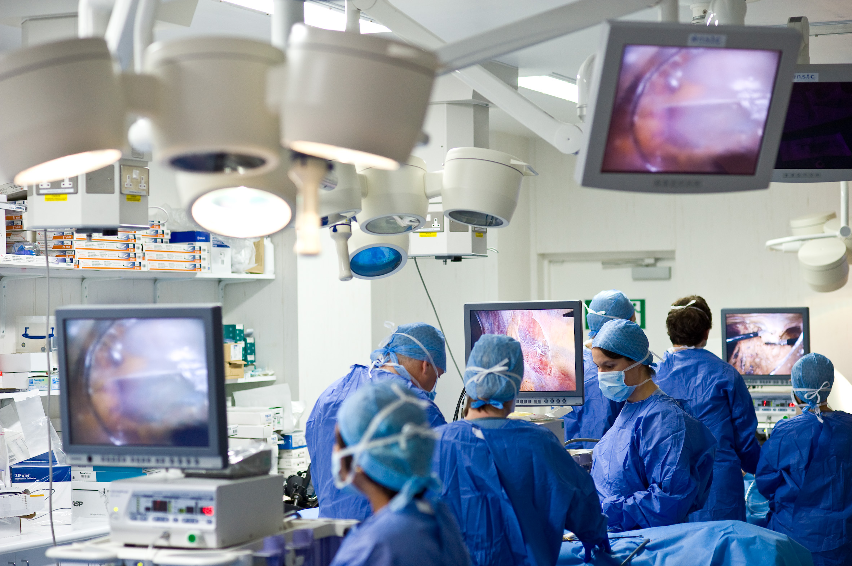

Full details and registration information at [**www.nstcsurg.org**](http://www.nstcsurg.org/)

**COURSE DIRECTORS**

**Mr Hugh Gallagher – Consultant Surgeon, RVI**

**Professor Michael Griffin Consultant Surgeon, RVI**

**FACULTY**

**Course Facilitator: Mr Brian Aspin** – Surgical Practitioner, RVI

**Mr Richard Bliss**, Consultant Surgeon, RVI

**Mr Bob Jarman, Consultant, A & E, RVI**

**Mr Arul Immanuel**, Consultant Surgeon, RVI

**Mr Jonathan Forty** Consultant Surgeon, Thoracic Trauma, Freeman

**Mr Euan Dickson** Consultant Hepatobiliary & Pancreatic Surgery, Glasgow Royal Infirmary

**Mr Mike Clarke** - Consultant Surgeon, FRH

**Mr Alan Sweenie –** Consultant Anaesthetist RVI

**Mr Angus Vincent –** Consultant Anaesthetist, RVI

**Surgeon Commander Chris Streets,** Consultant Surgeon, Bristol Royal Infirmary

**Mr Shlok Balapuri – Consultant Surgeon, Sunderland Royal**

Additional Faculty to be confirmed

**ADVANCED CADAVERIC TRAUMA SURGERY COURSE**

**FRESH FROZEN CADAVERS**

**Newcastle Surgical Training Centre**

**25-26 January 2016**

Or contact: Lorraine Waugh, Newcastle Surgical Training Centre

Freeman Hospital, Newcastle upon Tyne

Tel: (44) 191 24 48913 [Email: Lorraine.Waugh@nuth.nhs.uk](mailto:Email:%20Lorraine.Waugh@nuth.nhs.uk)



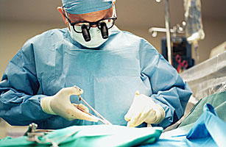



Newcastle Surgical Training Centre

Newcastle upon Tyne

Newcastle upon Tyne is a vibrant and friendly city situated at the end of the Roman Emperor Hadrian’s Wall, 3 hours from London by train and 45 minutes by plane. There is also a daily ferry from Europe. It sits in perhaps the most beautiful and historic region of England with its unspoiled sandy beaches and surrounding countryside with many castles dotted across the landscape. Newcastle boasts three large shopping centres, many fascinating museums as well as theatres, sport and leisure centres, art-centres and a rich variety of clubs, restaurants, bistros and coffee shops which would be well worth exploring during your stay.

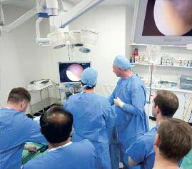

.................................................................................................................................................................

Surname: **..................**.................................................................................

I wish to attend the full course at a cost of

**£1100 – Dissector Places**

|**Non Dissectors: £175 – Nursing Professionals Only**

**TARGET AUDIENCE ST3-ST8, Consultants, SAS Grades**

Forename: **................................................................................................................................................**

Email…… …… …… …… …… …… …… …… …… …… …… …… …… …… ………… …… …… …….mark.dawesmark.dawes@nhs.netmar.......mark.dawes................................................................................................................................................

Department: ..............................................................................................................................................

Hospital Address: .....................................................................................................................................

This course is a two day hands on practical cadaveric workshop for surgeons, military or civilian who are relatively inexperienced in trauma but may be required to perform surgery on patients suffering traumaticinjuries under pressure in a trauma and emergency environment

* Pre-peritoneal packing (pelvic trauma) and
* Supracoeliac aortic control
* Splenectomy,
* Pringle manoeuvre,
* Liver mobilization/packing
* Exposure of femoral, Iliac, Popliteal Vessels
* Major Vascular Lower Body Injury
* Kocherisation, Pancreatic injury
* RtoL Visceral Medial rotation/ IVC Repair
* LtoR Visceral Medial rotation; renal repair and nephrectomy
* The Damage Control Philosophy
* Left Anterolateral Thoractomy
* Clamshell Thoracotomy
* Repair of Atrial and Ventricular Injuries

### Median Sternotomy

### Control of vessels

* Thoracic and Oesophageal Trauma
* Radiology of Trauma
* Approaches to the Hilum, Pulmonary Injuries, superior and posterior mediastinum.
* Closure and drains
* The Military Approach to Major Trauma
* Abdominal Trauma: The International Experience

**PROCEDURES INCLUDE**

Intensive two-day course

High faculty-to-participant ratio

Number of attendees limited to 12 dissector place and 12 non dissector places

Interactive classroom and cadaver instruction

Course dinner and all refreshments included

Course certificate & CPD accreditation (12 points)

**COURSE CONTENT**

**Please note:** The course fee will include: course dinner, lunch and refreshments.

Payment can be made via BACS (automatic bank transfer) by Credit Card, or by cheque payable to

Newcastle upon Tyne Hospitals NHS Trust. Full details and registration information at [**www.nstcsurg.org**](http://www.nstcsurg.org/)

Please note payment is due at registration to secure your place. Attendance on the course is conditional upon advance payment being received. Refunds cannot be given in the event of your cancellation within two weeks of the course date. The NSTC cannot accept liability for costs incurred in the event of a course having to be cancelled as a result of circumstances beyond its reasonable control.

**ADVANCED CADAVERIC TRAUMA SURGERY COURSE**

**25-26 January 2016 - Application Form**

Please indicate accordingly:

...................................................................................................... Postcode: ..........................................

Mobile Telephone:

How did you hear about this course? Trust website

Mailing

Other

...............Colleague..........................

**PLEASE STATE TO WHOM INVOICES SHOULD BE ADDRESSED, IF NO ALTERNATIVE CONTACT IS GIVEN, ALL INVOICES WILL BE DIRECTED TO THE APPLICANT**

**SPECIAL FEATURES OF THE COURSE**

Signed.......................................................................................................................................................

•

•

•

•

•

•

Vegetarian Please state any special dietary requirements:

.................................................................................................................................................................

..................................................................................................................................................................